**Requirements - Héli-charlevoix Project**

Link to the website: <http://www.heli-charlevoix.com/>

Feel free to ask questions if you are not sure on how to do something.

**To-Do**

**General**

* Make all pages responsive **(Done)**
* Fix any css bug that you encounter **(Done)**
* Make sure the website works on all browsers **(Done)**
* Clean all useless/unused css **(Done)**
* All content must be visible on any screen size. **(Done)**
* The arrow must be below the currently selected menu **(Done)**



* Increase the quality of this icon (change for a better one (available on Google))



**(Done)**

**Home page**

* Change the carousel to a mobile friendly one **(Done)**
* Fix the overlapping text in the box in the carousel **(Done)**

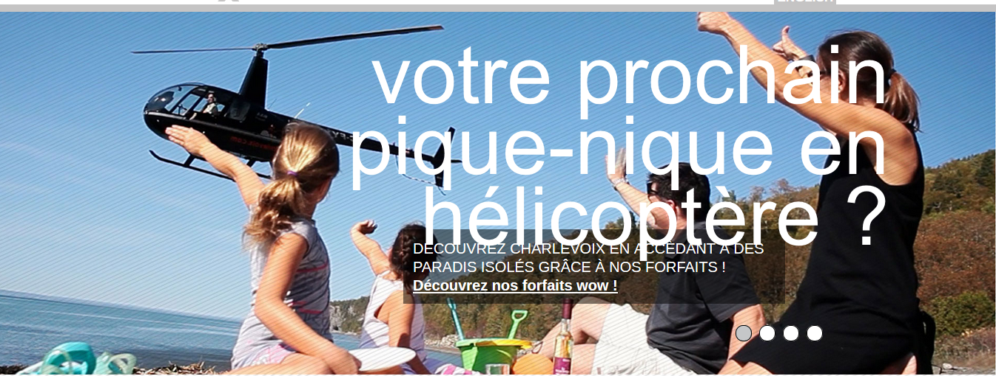

* Make sure these boxes have the same size (the difference is subtle, but there is one) **(Done)**



**Packages / forfaits Page**

* Remove the plus sign “+” from images. Create a CSS class so we can reuse it.

**(Done)**

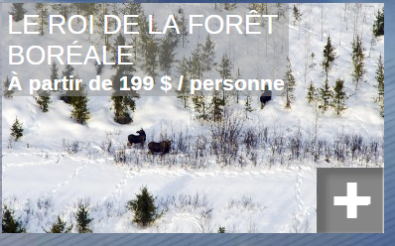

* Redo this from scratch (remove index field in umbraco, it’s badly done and limited to 6 elements). We want a simple loop of the elements ordered like in Umbraco. Make sure everything is responsive.

**(In Working)**

* We will update the pictures ourselves. Don’t bother on the “plus” included in the images.

**(Done we have upload 2 images on package.aspx page)**

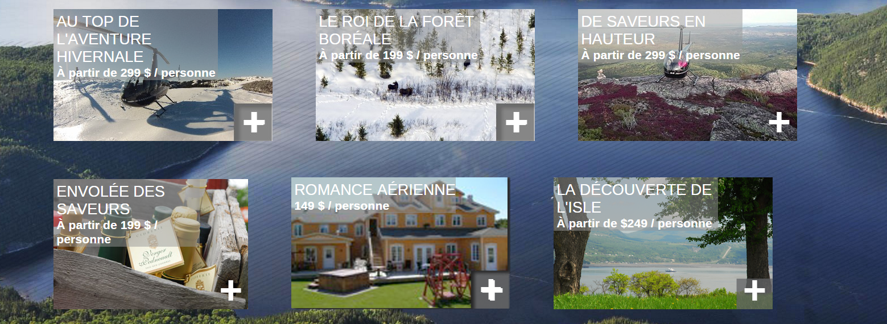

* When we’ll click on an item, we want it to « pop-up » in a fancy box.

**(Done)**

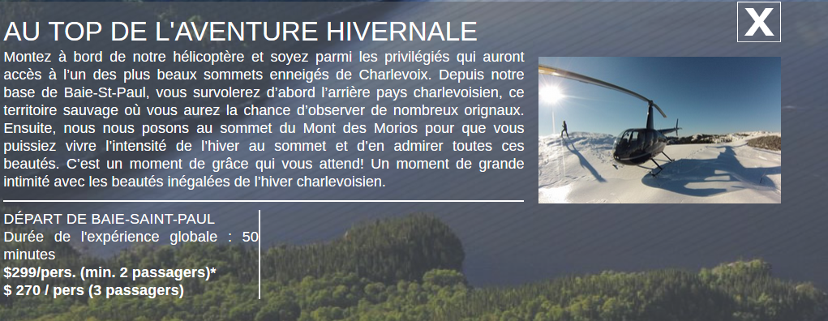

**Aerial work / Travail aérien page**

Remove the accordion. Sections should always be opened **(Done)**



**Info and advice / conseils et encadrement page**

Removed the accordion. Sections should always be opened **(Done)**

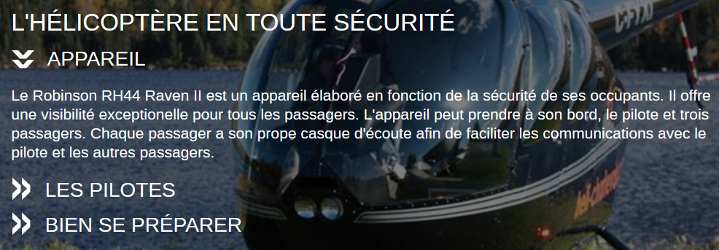

**Contact us and reserve / contact et réservation page**

* Fit this information in the map and improve the presentation.

**(Done)**

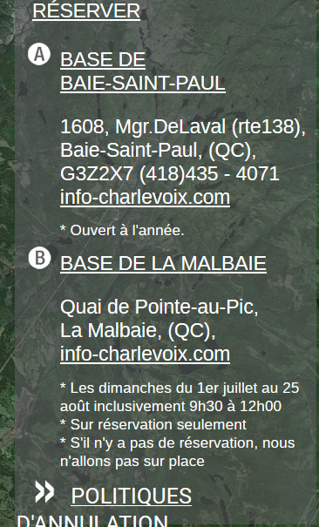

**(In Working)**

**Gallery / Galerie page**

* Remove the “vous êtes ici” link

**(Done)**

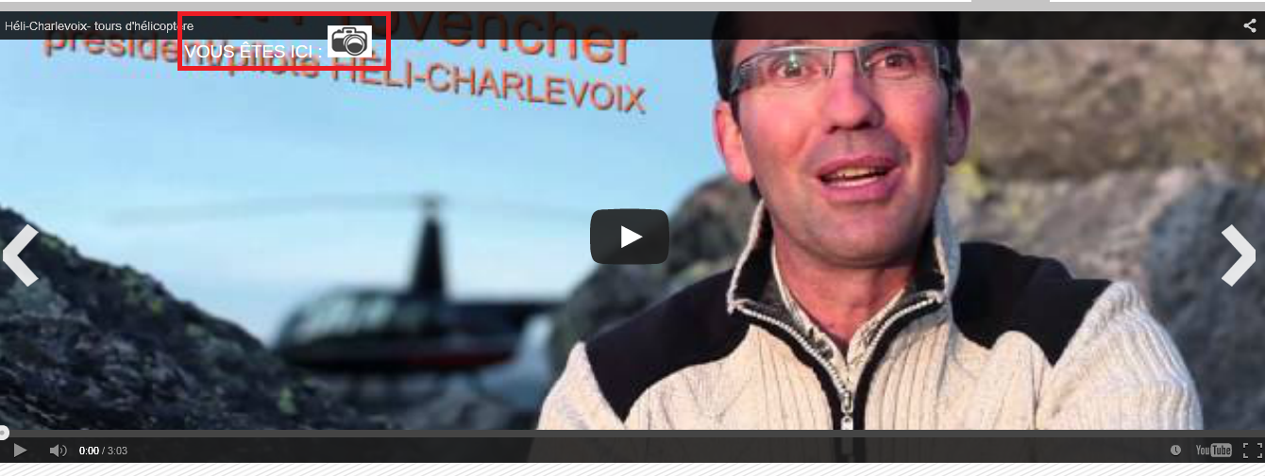

* Change the carousel / gallery plugin to a mobile friendly one **with thumbnail**

**(In Working)**

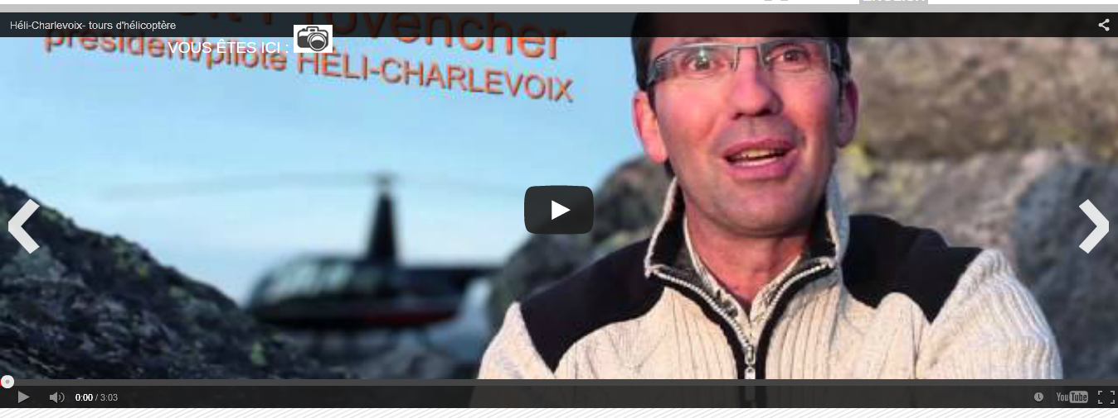

* Make sure the arrows are not clip (move them a little bit)



* Make the arrows appear only on hover on the carousel
* Make sure the carousel pager don’t overlap the text (do not use these pagers, use the pager of the plugin you will use)



* Put the same footer on all page. For example, this footer is different from the other pages.

**(In Working)**

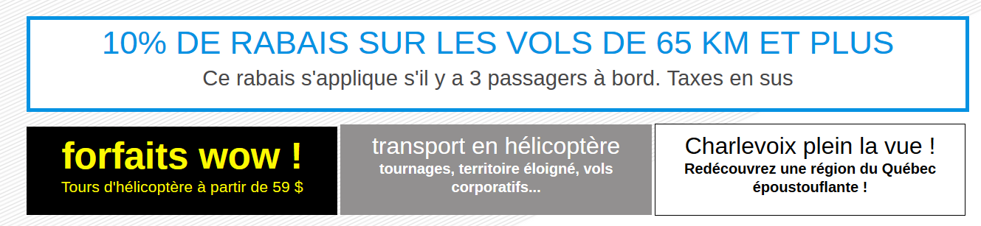

**Review of 26-03-2015 commit**

* Decrease the height of the menu like it was before on the website



* The arrow must be below the currently selected menu
  + The menu texts must be like they were before. Correct the alignment of the menu text.

**Done**

before: 

after:



* Increase the quality of this icon (change for a better one (available on Google))
  + Align the icon at right like it was before

before:

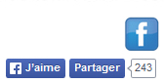

after:

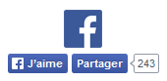

**(Done)**

* Change the carousel to a mobile friendly one (Done)

I want the carousel to be draggable by mouse and with the finger when we are on mobile (Maybe look for plugin like Slick or owl-carousel ?). **(Done)**

Change the bullet to more beautiful one **(Done)**



* Fix the overlapping text in the box in the carousel (Done) - Ok
* Make sure these boxes have the same size (the difference is subtle, but there is one) (Done) - Ok
* Remove the accordion. Sections should always be opened (Done) - Ok
* Fit this information in the map and improve the presentation. (Done) - Ok
* Remove the “vous êtes ici” link (Done) - Ok
* Put the same footer on all page. For example, this footer is different from the other pages. (Done) - Ok